**STAY FIT**

**Introduction**

Stay fit is a website designed for student athletes between the ages of 13-17. Main purpose of this web site is to provide young athletes a fun, and easy learning environment to become more aware about their day to day nutrition and fitness. This will help maximize athlete students’ performance in a specific sport they are engaged.

Stay Fit will permit coaches, and vendors for direct registering. students will register to the system once the school provides a verification and parents will register students following the verification from the school. Once student becomes member of Stay Fit she/he will have access to edit personal profile information, post messages, link their social media account, view information provided by vendors, create personal schedules, and post completed exercise. The website will also provide a user friendly map to help teens to search for local fitness facilities as well as details for certified fitness trainer.

Teachers and trainer will also be able to access the site once register. They will take parts in controlling students and vendors activities.

# **Requirements**

1. All of the features will reside on the website;
2. Website will contain this page's: personal profile, home page, team page, and a registration page for parents/coaches/vendors;
3. Registration process is different for different users:
   1. Students: school will provide a verification code to the Student, which expires within 5 business days and has to be re-requested from the school, which will be used by the Student's Parents when they register the student;
   2. School administration/Government Agents: after registering on the website will receive a registration link to their email addresses, which expires within 15 minutes, after confirming the email address through the link, account will have to be activated by an Administrator;
   3. Vendors: after registering on the website Vendor receives a link to upload documents (license), which will be further reviewed by the Administrators;
4. There will be 3 levels of user roles:
   1. Users: students will be given this role, they can:
      1. View the information provided on by the Vendors;
      2. Edit their profile information (change photos, edit statuses);
      3. Post messages;
      4. Link their social media (twitter) accounts;
      5. Create personal schedules;
      6. Post completed exercises.
   2. Moderator: Teachers/Trainers will be given this role, they can use it to:
      1. Approve student’s posts;
      2. Suspend students who post inappropriate posts (suspended accounts can view but cannot post anything to the website);
      3. Create team’s;
      4. Add students to the teams;
      5. Set team schedules;
      6. Confirm students attendance.
   3. Administrator: Teachers(not everyone, only selected by the school)/School Administration/Government Agents will have this role. This role provides access to this functions:
      1. Delete users;
      2. Add users;
      3. Change roles of users;
      4. Verify Vendors;
      5. All the functions of the Moderator.
      6. Set top sponsor for the month
5. Moderators/Administrators approve User posts with links/photos in them;
6. Administrators can set top sponsors each month that will be displayed in an advertisement/banner on the website that links to the sponsors page.
7. Service is based on the subscription model. Parents of the students will have to go through a payment procedure (using built in payment processor interface) to subscribe their child;
8. Vendors will be able to use the website to post their service and locations, after the verification process;
9. The website will provide a map to display local fitness facilities, as well as details for certified fitness trainers;
10. The website will track User's progress with achievements/badges for completing certain tasks;
11. Users will be able to form workout groups with other participating students;
12. Coaches and school officials will be able to view students’ participation on the website including posts, group activity, and achievements;
13. The system will handle payment processing securely and any personal data will be stored safely and viewable only to authorized users;
14. All stored data will be encrypted;
15. Credit card information will not be stored;
16. The product will cater to student athletes between the ages of 13-17;
17. Initial prototype will be rolled out for the Baltimore county;
18. The service will be accessible cross-platform (computer and mobile friendly);
19. A functioning demo will be presented in the mid-December time frame, with a status report roughly half way through the project;
20. Initial costs for a prototype will include support for a development team of 7 people over the course of 2-3 months, as well as purchasing of the server space. Future projected cost will increase for full-scale development and maintenance.

### **Project Organization**

* **Process Model**

The project follows the agile methodology of software development. The model follows an iterative circular progress of the development. It starts with Planning goes into Design then goes to Build stage then Testing stage and then Review. After the first iteration (sprint) is completed the developed part gets launched, and the next iteration gets started.

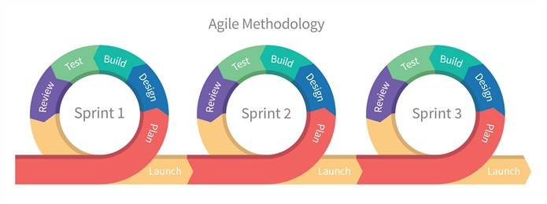

Figure 1. Agile Methodology. © Bikesh Srivastava, [LinkedIn article](https://www.linkedin.com/pulse/what-agile-methodologydisadvantage-waterfall-model-bikesh-srivastava/)

* **Organizational Structure**

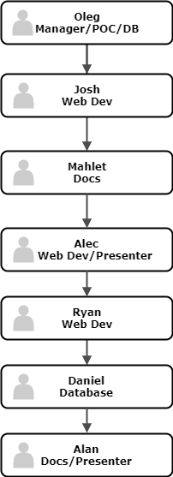

* **Organizational Interfaces**

Our team will interact with these external entities:

* Client;
* Provider of the payment processor system;
* Heroku: cloud application platform;
* Amazon AWS – cloud hosting;
* Google Domains.

### **Managerial Process**

* **Management Objectives and Priorities**
  + The priorities among the requirements include:
    - A web forum for students to post to that can be seen and monitored by school administrators and coaches
    - A page that helps students connect with fitness trainers and dieticians
    - An interactive map that displays local fitness centers
    - An achievement tracker that shows a student’s fitness progress as they achieve goals
    - Ability for students to share their fitness achievements on social media
  + A functioning demo will be presented in the mid-December time frame, with a status report roughly half way through the project.
  + Initial costs for a prototype will include support for a development team of 7 people over the course of 2-3 months, as well as purchasing a server space.  Future projected cost will increase for full-scale development and maintenance.
* **Assumptions, Dependencies and Constraints**
  + The project depends on government funding and public interest among schools and students.
  + The project is on a time constraint to have a functioning demo by mid-December.
* **Risk Management**
  + Staff risk is possible if people leave the project. In this case other project members would have to take on a bigger role.
  + Client acceptance risk is possible if the client does not like what they are presented during the prototype development. In this case the project would have to be modified in order to meet the client’s needs.
* **Monitoring and Controlling Mechanisms**
  + Frequency and mechanisms for reporting
  + Staff meetings will be held weekly to make sure everyone is on the same page.
  + Developers will constantly push their work onto a shared GitHub repository to ensure code works with other’s without breaking anything.
* **Staffing Plan**
  + The project will require a group of seven people, three web developers, three database developers, and a presenter.

### **Methods, Tools, Techniques:**

* Application to be hosted on Heroku
  + Deployed to Heroku directly from Github repository; changes pushed with each commit to the master branch
* Database to be hosted hosted on Heroku with Postgres
  + Heroku dyno storage is ephemeral; need a permanent hosting solution for data
* Ruby on Rails implementation
  + Model-View-Controller framework
  + Provides default structures for web service, database, web pages
  + Very good support and documentation on Heroku page, as well as third parties

### **Software Documentation:**

* Methods to be documented, javadocs-style
  + Generated from code whenever methods are added/changed
  + Devs able to keep track of others’ components and adjust use/implementation of interfaces and calls between sections of code
* Github
  + Useful commit messages to keep track of what changes are pushed
  + Separate components developed in different branches
* A help page to be developed alongside the rest of the UI/web pages
  + Will document the site for end-users
  + Will describe basic functionality, and special cases which might require more instructions (if such scenarios arise)

### **Project Support**

* QA
  + Testing of code and functionality throughout development process
  + Code reviews
* Configuration Management
  + Version control through Github
  + Stable releases marked as such and developed separately
    - Support for previous versions can be provided if necessary
* Verification and Validation
  + Working demos periodically shown to the client to ensure correct implementation of requirements
  + As requirements are changed/clarified, changes will be documented and confirmed with the client